Control-Flow Logic – Exercises
Exercises and homework assignments for “Introduction to Programming with AI” course at SoftUni.
Judge submission link: https://alpha.judge.softuni.org/contests/exercises-control-flow-logic/5272.

Odd or Even
Write a function to check if given number is odd or even. Return a string “odd” or “even”, depending on the input number, passed as a parameter.

Input and Output
Input | Output
console.log(oddOrEven(3)); | odd
console.log(oddOrEven(12)); | even

Hints
First, create a folder to keep all your code from the “Control-Flow Logic” exercises and open it in Visual Studio Code. Give it a reasonable name, e.g. “Control-Flow”:
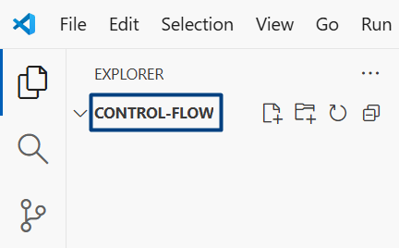
Create a new JS file, which will hold your code. Give it a reasonable name, e.g. “odd-or-even.js”:
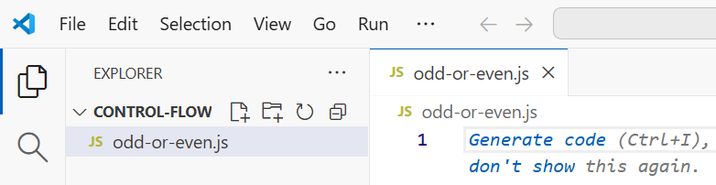
Now, define the function and use if-else statement to implement its logic. This is a sample implementation:
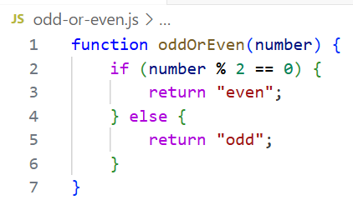

Judge Submission
Submit your code to the judge here: https://alpha.judge.softuni.org/contests/exercises-control-flow-logic/5272.

Visualize with HTML
Visualize the function with HTML: enter a number, invoke the function and visualize its output.
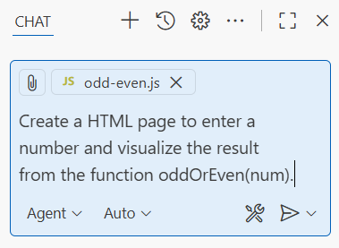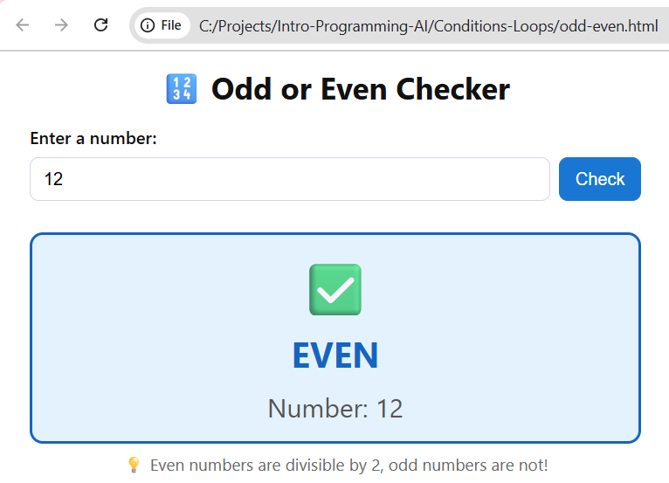

Greater of Two Numbers
Write a function to return the greater of two numbers.

Input and Output
Input | Output
console.log(greaterNumber(5, 7)); | 7
console.log(greaterNumber(12, 5)); | 12

Hints
Create a new JS file for your solution. Give it a reasonable name, e.g. “greater-number.js”.
Define your function (initially empty): function greaterNumber(num1, num2) { }.
Use if-else to implement its logic: if num1 is greater than num2, return num1. Otherwise, return num2.
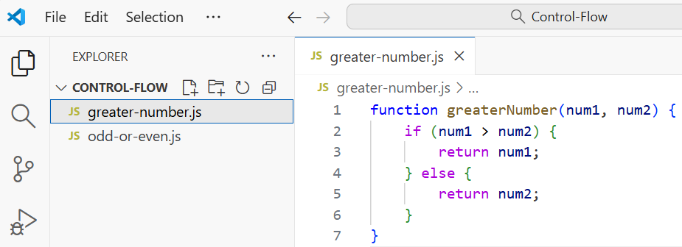

Judge Submission
Submit your code to the judge here: https://alpha.judge.softuni.org/contests/exercises-control-flow-logic/5272.

Visualize with HTML
Visualize the function with HTML: enter two numbers, invoke the function and visualize its output.
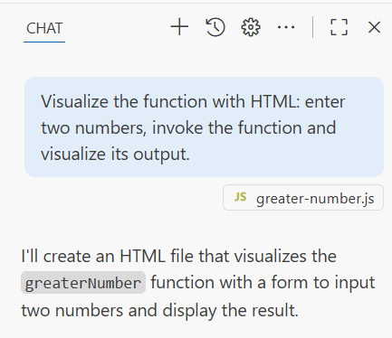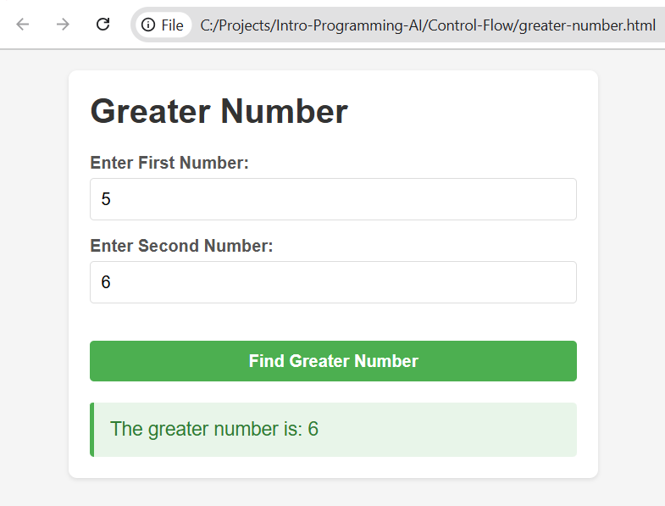

Greater of Three Numbers
Write a function to return the greater if three numbers, passed as parameters.

Input and Output
Input | Output
console.log(greaterNumber(5, 7, 6)); | 7
console.log(greaterNumber(12, 5, 15)); | 15
console.log(greaterNumber(10, 5, 8)); | 10

Hints
Create a new JS file for your solution. Give it a reasonable name, e.g. “greater-of-3-numbers.js”.
Define your function (initially empty): function greaterNumber(num1, num2, num3) { }.
Use if-else to implement the function logic:
- Variant 1: use “if with &&”
  - If num1 is greater or equal to num2 and at the same time num1 is greater or equal to num3, then return num1.
  - Do the same check for num2 and num3.
- Variant 2: use nested if-else statements.
Submit your code for evaluation to the judge system.

Visualize with HTML
Visualize the function with HTML: enter 3 numbers, invoke the function and visualize its output.

Number 1...9 as Words
Write a function to return a number in the range [1…9] as words in English.

Input and Output
Input | Output
console.log(numToWords("5")); | five
console.log(numToWords("9")); | nine
console.log(numToWords("15")); | out of range

Hints
Create a new JS file for your solution. Give it a reasonable name, e.g. “num-1-9-as-words.js”.
Define your function (initially empty): function numToWords(num) { }.
Use switch-case to check for numbers 1, 2, …, 9. Return the corresponding text as a result for each matched number or “out of range” when no case is matched.

Visualize with HTML
Visualize the function with HTML: enter a number, invoke the function and visualize its output.

Number 0...100 as Words
Write a function to return a number in the range [0…100] as words in English.

Input and Output
Input | Output
console.log(numToWords("0")); | zero
console.log(numToWords("1")); | one
console.log(numToWords("7")); | seven
console.log(numToWords("12")); | twelve
console.log(numToWords("13")); | thirteen
console.log(numToWords("20")); | twenty
console.log(numToWords("29")); | twenty-nine
console.log(numToWords("78")); | seventy-eight
console.log(numToWords("100")); | one hundred
console.log(numToWords("120")); | >> out of range <<
console.log(numToWords("1.5")); | >> out of range <<

Hints
Create a new JS file for your solution. Give it a reasonable name, e.g. “num-to-words.js”.
Define your function (initially empty): function numToWords(num) { }.
Writing a correct solution by hand will be challenging for most people. You can consider these cases:
- 0…20 use switch-case to return the correct text.
- 20 … 29 return “twenty” + last digit (0…9) as words.
- 30 … 39 return “thirty” + last digit (0…9) as words.
- …
- 90 … 99 return “ninety” + last digit (0…9) as words.
- 100 return “one hundred”.
- Otherwise return “>> out of range <<”.
It will be easier and faster to run a prompt in GitHub Copilot to write a solution.

Visualize with HTML
Visualize the function with HTML: enter a number, invoke the function and visualize its output.

Area of Figures
Write a function to calculate the area of given figure. Figures are 3 types: square, rectangle, circle.

Input and Output
Your function should take 3 parameters: figure, dimension1, dimension2 (optional). The figure should be “square”, “rectangle” or “circle”. All other figures are considered invalid.
- Squares have width (dimension1).
- Rectangles have width (dimension1) and height (dimension2).
- Circles have radius (dimension1).
Return the calculated area, rounded to the 2nd decimal in the format like the below examples:
Input | Output
console.log(figureArea("square", 5)); | square area = 25.00
console.log(figureArea("rectangle", 2.5, 7.85)); | rectangle area = 19.63
console.log(figureArea("circle", 1.5)); | circle area = 7.07
console.log(figureArea("rhombus", 30, 50)); | Invalid figure!

Hints
Use if-else to match different figures and use the corresponding formula to calculate their area.

Visualize with HTML
Visualize the function with HTML: choose figure (from a dropdown box), enter figure dimensions, invoke the function and visualize its output. Sample visualization:
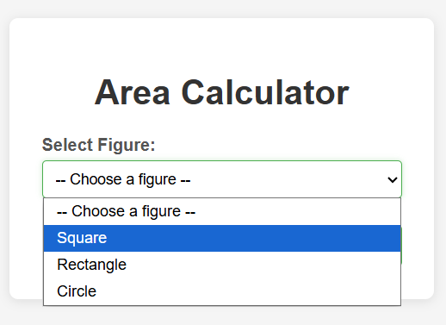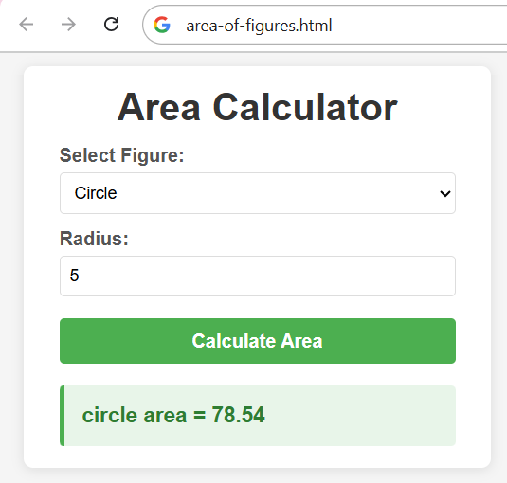

Coffee Shop
Write a function to calculate the price for a drink by given drink and optional extras.
- Drinks are either "coffee" or "tea".
- Drinks may have extras (optionally): either "sugar" or "creamer" or both.
Prices are as follows:
- Coffee: 1.00
- Tea: 0.60
- Soda: 1.20
- Sugar: 0.40
- Creamer: 0.30

Input and Output
Your function takes 1, 2 or 3 parameters: drink name (mandatory), extra1 (optional), extra2 (optional).
Return the price as a string in format “Final price: {price}”, rounded to 2 digits after the decimal point.
If the drink is unknown return “Invalid drink!”. If an unknown extra is found, return “Invalid extra!”.
Input | Output
console.log(drinkPrice("coffee", "sugar")); | Final price: 1.40
console.log(drinkPrice("coffee", "creamer", "sugar")); | Final price: 1.70
console.log(drinkPrice("tea")); | Final price: 0.60
console.log(drinkPrice("tea", "sugar")); | Final price: 1.00
console.log(drinkPrice("water"")); | Invalid drink!

Hints
- Start from price = 0.
- Use if-else to check the drink name and add its price (or return “Invalid drink!”).
- Use if-else to check the first extra and add its price (or return “Invalid extra!”).
- Use if-else to check the second extra and add its price (or return “Invalid extra!”).
- Return the final price in the required format.

Visualize with HTML
Visualize the function with HTML: choose a drink (from a dropdown box), choose an extra 1 (from a dropdown box), choose an extra 2 (from a dropdown box), invoke the function and visualize its output. Sample visualization:
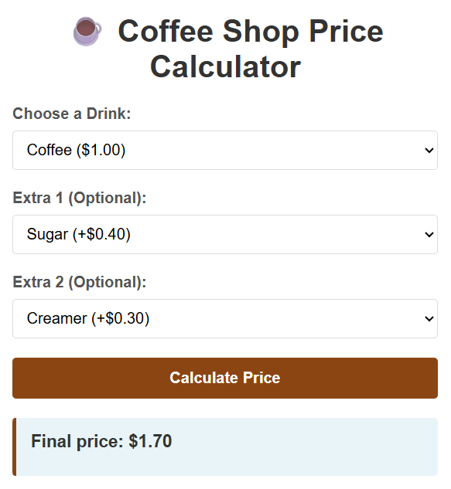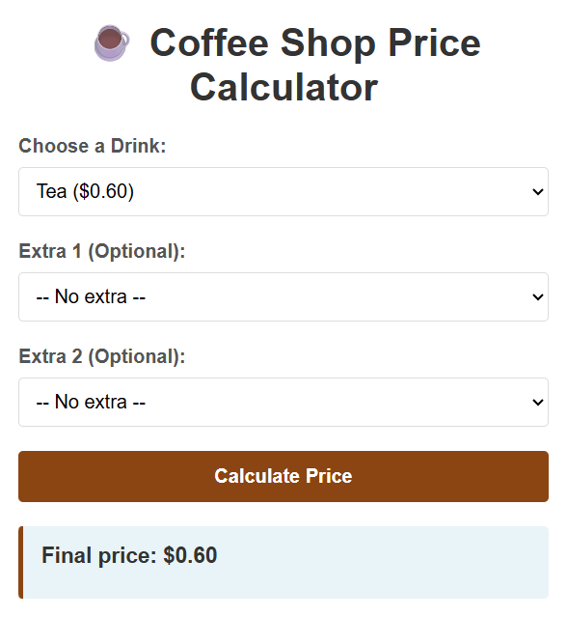

Hotel Prices
Write a function to calculate the prices for renting a studio or apartment in a hotel, according to the price table and the discounts described below:
 | May, October  (low season) | June, September  (mid season) | July, August  (high season) | November – April  (out of season)
Studio | 50.00 | 70.00 | 80.00 | 40.00
Apartment | 65.00 | 80.00 | 95.00 | 55.00
The price is calculated based on the start date of the hotel stay.
The following discounts are additionally offered:
- For a studio, with 7 nights or more, regardless of the month: 5% discount.
- For a studio, with 14 nights or more in July or August: 15% discount.
- For a studio, with 14 nights or more in June or September: 20% discount.
- For a studio, with 14 nights or more in all other months: 30% discount.
- For an apartment, with 7 nights or more, in May – October: 5% discount.
- For an apartment, with 14 nights or more, regardless of the month: 10% discount.
Apply up to one discount – the biggest applicable.

Input and Output
You will be given a start date and an end date in format dd-MMM-yyyy. You should return the number of nights and the price for studio and price for apartment for the specified period. Follow the sample input and output:
Input | console.log(hotelPrice("12-Feb-2026", "14-Feb-2026"));
Output | 2 nights  Studio price: 80.00  Apartment price: 110.00
Comments | Duration: 2 nights, out of season  Studio price: 2 nights x 40.00 = 80.00  Apartment price: 2 nights x 55.00 = 110.00  Short stay no discounts

Input | console.log(hotelPrice("25-Jun-2026", "5-Jul-2026"));
Output | 10 nights  Studio price: 665.00  Apartment price: 760.00
Comments | Duration: 10 nights, mid season  Studio price: 10 nights x 70.00 = 700.00 - 5% discount = 665.00  Apartment price: 10 nights x 80.00 = 800.00 - 5% discount = 760

Input | console.log(hotelPrice("10-May-2027", "25-May-2027"));
Output | 15 nights  Studio price: 525.00  Apartment price: 877.50
Comments | Duration: 15 nights, low season  Studio price: 15 nights x 50.00 = 750.00 - 30% discount = 525.00  Apartment price: 15 nights x 65.00 = 975.00 - 10% discount = 877.50

Input | console.log(hotelPrice("20-July-2027", "3-Aug-2027"));
Output | 14 nights  Studio price: 952.00  Apartment price: 1197.00
Comments | Duration: 14 nights, high season  Studio price: 14 nights x 80.00 = 1120.00 - 15% discount = 952.00  Apartment price: 14 nights x 95.00 = 1330.00 - 10% discount = 1197.00

Input | console.log(hotelPrice("20-July-2027", "3-Jun-2027"));
Output | Invalid period!

Hints
- First, calculate the number of nights from the given start date and end date. Check for invalid period.
- Extract the month from the start date.
- Calculate the regular prices for studio and apartment (without any discounts) for the given month.
- Calculate the discounts for studio and apartment, based on the number of nights and the month.
- Apply the discounts and return the expected output.

Visualize with HTML
Visualize the price calculation with HTML: choose a start date and an end date, invoke the function and visualize its output in a reasonable way. This is a sample visualization:
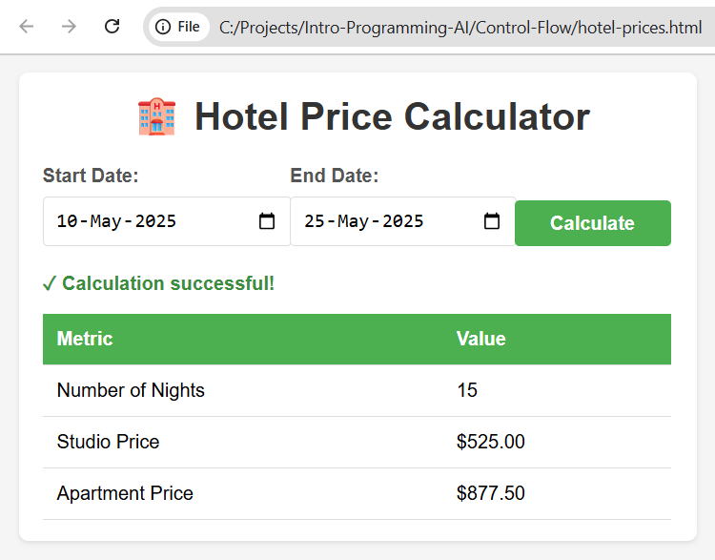

Cosine and Sine
Write a function to print all degrees in given range (e.g. from 45° to 180°) and their cosine and sine.

Input and Output
The input range is specified by two integers: start and end, where 0 ≤ start ≤ end ≤ 360.
Print the cosine and sine rounded to 4 digits after the decimal point in the below format:
Input | printDegreesCosineSine(45, 55);
Output | 45 degrees: cos = 0.7071, sin = 0.7071  46 degrees: cos = 0.6947, sin = 0.7193  47 degrees: cos = 0.6820, sin = 0.7314  48 degrees: cos = 0.6691, sin = 0.7431  49 degrees: cos = 0.6561, sin = 0.7547  50 degrees: cos = 0.6428, sin = 0.7660  51 degrees: cos = 0.6293, sin = 0.7771  52 degrees: cos = 0.6157, sin = 0.7880  53 degrees: cos = 0.6018, sin = 0.7986  54 degrees: cos = 0.5878, sin = 0.8090  55 degrees: cos = 0.5736, sin = 0.8192

Hints
- Create a new JS file for your solution. Give it a reasonable name, e.g. “cosine-sine.js”.
- Define your function (initially empty): function printDegreesCosineSine(start, end) { }.
- Use a for-loop to iterate from start to end, calculate the cosine and sine and print them.

Visualize with HTML
Visualize the results with HTML: enter a start number and end number (in range 0…360), invoke the function and visualize its output as table, holding degrees, cosine and sine values.
Plot these values on the coordinate system, where the x-axis represents the degree values and the y-axis represents the cosine and sine values. Use green dots to plot the cosine values and blue dots to plot the sine values.
This is a sample visualization of the degree, cosine and sine values in given range:
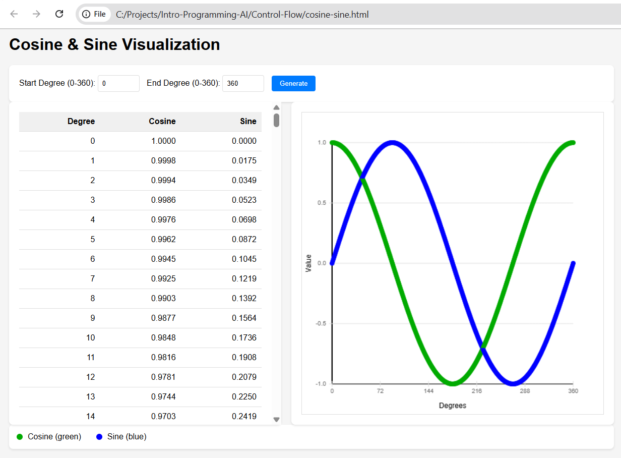

Numbers Sum
Write a function numbersSum(n) to return the sum of all numbers 1…n in the below format.

Input and Output
Input | Output
console.log(numbersSum(3)); | 1 + 2 + 3 = 6
console.log(numbersSum(5)); | 1 + 2 + 3 + 4 + 5 = 15
console.log(numbersSum(7)); | 1 + 2 + 3 + 4 + 5 + 6 + 7 = 28

Hints
- Create a new JS file for your solution. Give it a reasonable name, e.g. “numbers-sum.js”.
- Use a for-loop to iterate from 1 to n. In the loop body calculate the sum and append the next number to the output, together with the ‘+’ sign.

Visualize with HTML
Visualize the results with HTML: enter a number, invoke the function and visualize its output.

Numbers Ending in 7
Write a function numbersEndingIn7(n) to print all numbers from 7 to n, ending in 7.

Input and Output
Input | numbersEndingIn7(28); | numbersEndingIn7(37);
Output | 7  17  27 | 7  17  27  37

Hints
Use a for-loop, starting from 7, using a step of 10.

Visualize with HTML
Visualize the results with HTML: enter a number, invoke the function and visualize its output.

Letters in Range
Write a function lettersInRange(startLetter, endLetter) to return all letters in given range of letters.

Input and Output
Input | Output
console.log(lettersInRange('a', 'f')); | a b c d e f
console.log(lettersInRange('k', 'q')); | k l m n o p q
console.log(lettersInRange('g', 'q')); | g h i j k l m n o p q

Hints
Learn about letters and their char codes (ASCII / Unicode codes):
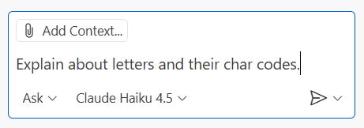
Extract the input letters first from the input strings and take their char codes, then use a for-loop to iterate from the start to the end char code and append each letter (created from the current char code) into the output.

Visualize with HTML
Visualize the results with HTML: enter two letters, invoke the function and visualize its output.

Vowels Sum
Write a function to sum the vowels of given word (or text), according to the table below:
Character | a | e | i | o | u
Value | 1 | 2 | 3 | 4 | 5

Input and Output
Input | Output | Comments
console.log(sumVowels("hello")); | 6 | Vowels: e = 2, o = 4  2 + 4 = 6
console.log(sumVowels("SoftUni")); | 12 | Vowels: o = 4, u = 5, i = 3  4 + 5 + 3 = 12
console.log(sumVowels("JavaScript")); | 5 | Vowels: a = 1, a = 1, i = 3  1 + 1 + 3 = 5

Hints
- Convert the input text to lowercase.
- Iterate over the letters with a for-loop and count each vowel letter with if-else.

Visualize with HTML
Visualize the results with HTML: enter a text, invoke the function and visualize its output.

Sum of Digits
Write a function to calculate the sum of digits of given integer number.

Input and Output
Input | Output | Comments
console.log(sumDigits(1712)); | 11 | 1 + 7 + 1 + 2 = 11
console.log(sumDigits(985625)); | 35 | 9 + 8 + 5 + 6 + 2 + 5 = 35

Hints
While the number is > 0, take its last digit (num % 10), sum it and remove it: num = Math.floor(num / 10).

Visualize with HTML
Visualize the results with HTML: enter an integer number, invoke the function and visualize its output.

Triangle of Stars
Write a function to return a triangle of stars of size n like shown below.

Input and Output
Input | console.log(triangle(3)); | console.log(triangle(6));
Output | *  **  *** | *  **  ***  ****  *****  ******

Hints
Use nested loops: outer loop 1…n, inner loop 1…n.

Visualize with HTML
Visualize the results with HTML: enter an integer number, invoke the function and visualize its output.

Building
Write a function to print a table, representing a building:
- Odd floors hold apartments (type A), e.g. A10, A11, A12, …
- Even floors hold offices (type O), e.g. O20, O21, O22, …
- The last floor holds large apartments (type L), e.g. L60, L61, L62
- Identifiers of units consist of {type}{floor}{number}, e.g. L65, A12, O24

Input and Output
The input comes as two parameters: number of floors and number of units per floor.
Input | printBuilding(6, 4); | printBuilding(3, 7);
Output | L60 L61 L62 L63  A50 A51 A52 A53  O40 O41 O42 O43  A30 A31 A32 A33  O20 O21 O22 O23  A10 A11 A12 A13 | L30 L31 L32 L33 L34 L35 L36 L37  O20 O21 O22 O23 O24 O25 O26 O27  A10 A11 A12 A13 A14 A15 A16 A17

Hints
Use nested loops: outer loop floors down to 1, inner loop 1…units.

Visualize with HTML
Visualize the results with HTML: enter two integers (number of floors and number of units per floor), invoke the function and visualize its output.

Stupid Passwords
Write a function, which generates all possible passwords, consisting of the following 3 parts:
- The first part is an even number in the range [2…n]
- The second digit is an odd number in the range [1…n]
- The third is the product of the first two
Sample password, constructed following the above rules:
- 4312 4 (even number) * 3 (odd number) = 12 (multiplication)

Input and Output
The input is the number n. The output should hold all possible passwords, in incremental order, space separated.
Input | Output
stupidPasswords(5); | 212 236 2510 414 4312 4520
stupidPasswords(6); | 212 236 2510 414 4312 4520 616 6318 6530
stupidPasswords(11); | 212 236 2510 2714 2918 21122 414 4312 4520 4728 4936 41144 616 6318 6530 6742 6954 61166 818 8324 8540 8756 8972 81188 10110 10330 10550 10770 10990 1011110

Hints
Use nested loops: outer loop [2 … n] with step=2, inner loop [1 … n] with step=2.

Visualize with HTML
Visualize the results with HTML: enter an integer, invoke the function and visualize its output.

Combinations of 3 Letters
Write a function to generate all 3-letter combinations under certain conditions:
- Take as input start letter s, end letter e and excluded letter x.
- Print all combinations of 3 letters in the range [s…e], excluding x.
- Print their total count at the start.

Input and Output
Input | Output
threeLettersCombinations('a', 'c', 'b'); | Total count: 8  aaa aac aca acc caa cac cca ccc
threeLettersCombinations('p', 't', 'q'); | Total count: 8  ppp ppr pps ppt prp prr prs prt psp psr pss pst ptp ptr pts ptt rpp rpr rps rpt rrp rrr rrs rrt rsp rsr rss rst rtp rtr rts rtt spp spr sps spt srp srr srs srt ssp ssr sss sst stp str sts stt tpp tpr tps tpt trp trr trs trt tsp tsr tss tst ttp ttr tts ttt

Happy Numbers
Write a function to generate all 4-digit happy numbers, in the format {d1}{d2}{d3}{d4}, for given integer n:
- A number is considered happy if d1 + d2 == d3 + d4 == n
- A number cannot start with zero

Input and Output
Input | Output
happyNumbers(3); | 1203 1212 1221 1230 2103 2112 2121 2130 3003 3012 3021 3030
happyNumbers(4); | 1304 1313 1322 1331 1340 2204 2213 2222 2231 2240 3104 3113 3122 3131 3140 4004 4013 4022 4031 4040

Hints
Use several nested loops for each digit.

Visualize with HTML
Visualize the results with HTML: enter an integer, invoke the function and visualize its output. Illustrate in a visual way how the sum of digits work.

